(Approx. 683 words)

Tiny Icons for Big Functions
Author: Nancy DeMarte, 1st Vice President,
Sarasota Technology Users Group, FL
July 2019 issue, Sarasota Monitor
www.thestug.org - nanellend (at) gmail.com

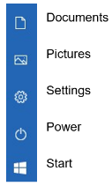
In recent years, the number of functions that computers and other devices can perform has increased greatly. It appears that to make more room on the screen, tech companies have reduced the amount of text and replaced it with symbols or icons, often without giving users notice. A good example is Google’s block of dots representing their many apps. One day about a year ago I found my Gmail contacts list was missing. Eventually, I found it in the center of the Google app icon (shown at right) on the Google home page. This change to icons was so subtle that many users didn’t notice it until they couldn’t find a tool or function.

The trend is not only on the Internet, but also in Microsoft’s Windows and Office apps. When I click the Windows 10 Start button, I see a list of important functions represented by icons. Fortunately, Microsoft has tried to make each icon resemble its name, as shown below. But not all the icons are as obvious as the gear for Settings or a house to indicate the Home page.
In Office, some icons are so small that they are easy to miss. On the Home tab in Word, for example, several of the groups of tools have a tiny diagonal arrow in the lower right corner. Clicking this icon in the Font group opens a dialogue box which lets me set specific properties for text, as shown. I can make my choices and, if I wish, set them as the default font, meaning that these settings will remain until I change them.
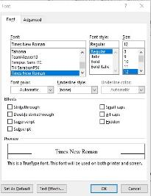
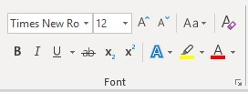
Similar results are found throughout the Office applications.
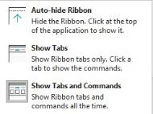
Another useful, but tiny icon in Windows is often overlooked. It is called ‘Ribbon Display Options’ and is located at the right end of the bar at the top of the Windows and Office screens. If I want to increase the visible space for typing in Word, I click this icon and choose to hide the ribbon or show only the tabs. It would be hard to guess what this icon means.

One of my favorite icons in Word is ‘Layout Options.’ When I insert a picture or object into a document, it is accompanied by the icon shown at the left. Its function is to allow a picture to fit smoothly with the text. I click the icon and choose how I want it to interact with text. It can wrap the text around the photo (as shown) or have it appear in front of or behind the text, among other options.

Internet browsers use icons widely, too. Firefox, my current browser, uses icons in the address bar: three dots to indicate ‘More information or tools,’ and a star icon to open my bookmark list. The icon in the center lets me view my Pocket contents. Pocket is a personal online storage library for articles, videos, etc. that I have copied from many sources. It was developed by Mozilla, the company that created Firefox, and is available for iOS and Android devices as well as computers. Search the web for Pocket to learn more about its features.

On the Firefox home page is an icon group that includes my search history, bookmark sidebars, Last Pass (a password keeper), and an icon for my account which also can synchronize Firefox history and bookmarks with my other devices. Can you identify their icons in the illustration? The three lines at the end of the Firefox icon group give me access to several settings and functions of Firefox.

As you can see, not all icons match their functions. You can avoid frustration by holding your mouse pointer over an icon to see at least its name. Better yet, click the icon and explore its content. Don’t be intimidated by these icons, but don’t ignore them either. Look around the screen. Some of the most helpful tools and information can be found by clicking those tiny icons.

